***Cloudera Manager 7 Installation-Steps***

1. Register an account: https://sso.cloudera.com/onboarding.html?stepId=pocForm
2. Get installer for CDP Installer (60 Days Trial) https://www.cloudera.com/downloads/cdp-private-cloud-trial/cdp-private-cloud-base-trial.html
3. Check for supportable Linux OS(Ubuntu 20.04 or Centos) .Supporting OS : <https://supportmatrix.cloudera.com/>, and get Ubuntu 20.04, https://releases.ubuntu.com/20.04/ubuntu-20.04.4-desktop-amd64.iso
4. Request Trial at <https://www.cloudera.com/downloads/cdp-private-cloud-trial/cdp-private-cloud-base-trial.html>
5. Install Cloudera Manager with steps below( they are mentioned in the URL above too):
   1. Download Cloudera Manager Installer and install:
   2. $ wget <https://archive.cloudera.com/cm7/7.4.4/cloudera-manager-installer.bin>
   3. $ chmod u+x cloudera-manager-installer.bin
   4. $ sudo ./cloudera-manager-installer.bin
6. Once installer completes, create SSH user( cdproot) with Root/Admin Privileges

Option-1:  
 sudo adduser cdproot

sudo usermod -aG sudo cd root

Option-2:

sudo adduser cdproot sudo

Checks: groups cdproot

1. Install and start OpenSSH-Server to run at 22

# sudo apt-get install openssh-server

# sudo systemctl enable ssh

# sudo systemctl start ssh

1. SSH Login and Root Permission:
   1. SSH Login:

sudo nano /etc/ssh/sshd_config

or

sudo nano /etc/ssh/sshd_config

Add This : PermitRootLogin yes

* 1. Root User:

sudo gedit /etc/sudoer and allow NOPASSWRD logins

1. Start SCM Server sudo service cloudera-scm-server start  
   Other options:   
   sudo service cloudera-scm-server start

sudo service cloudera-scm-server stop

sudo service cloudera-scm-server restart

1. Access Cloudera Manager at https://<ip>:7180, username/password admin/admin/
2. Follow on-screen details to install and configure all parcels/packages

(Works in most scenarios)...

***Cloudera Data Platform installation using Cloudera Manager 7:***

Now, follow the steps below to complete installation of CDP :

1. Login to Cloudera Manager 7 with given URL [http://54.255.20.131:7180](http://54.255.20.131:7180/) and credentials
2. Click on continue and define Cluster, Cluster-BS

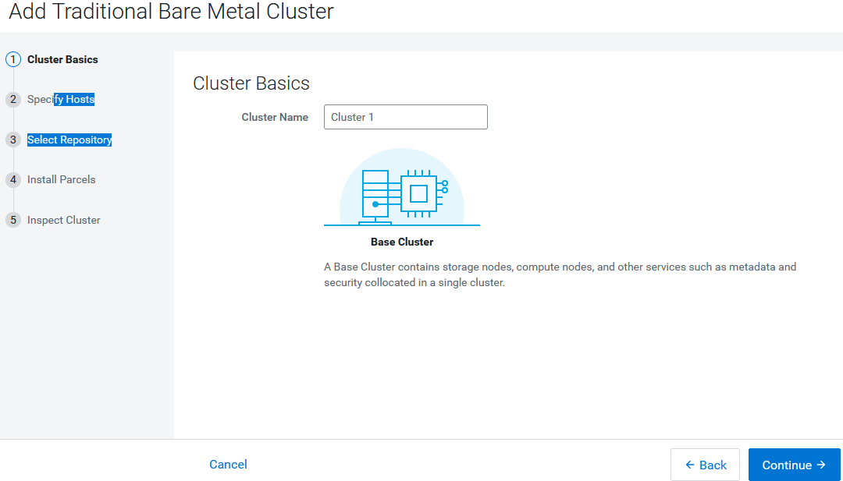

1. Click on continue and search the server system by Hostname

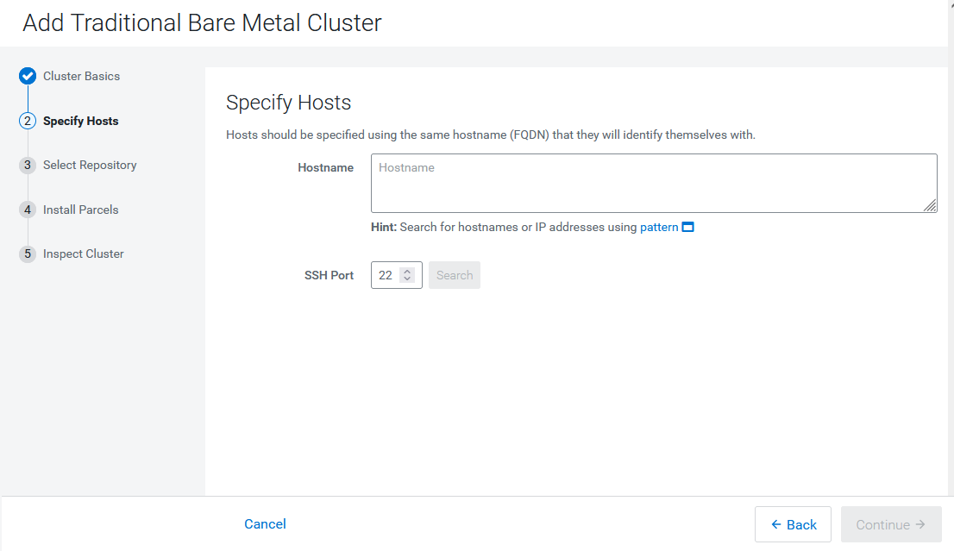

1. Before clicking Continue create another user with root permission/privileges

Option-1:  
 sudo adduser cdproot

sudo usermod -aG sudo cd root

Option-2:

sudo adduser cdproot sudo

Checks: groups cdproot

1. Permit RootLogin

sudo nano /etc/ssh/sshd_config

Add This : PermitRootLogin yes

sudo gedit /etc/sudoer and allow NOPASSWRD logins

1. Click next and select “System JDK” and continue, need start installing all packages.
2. Refer “***InstalltionDetails- SCU.pdf”*** from [Santa Clara University](https://www.scu.edu/) .

All Developer Addon-Tools Installations:

1. Clouder Data Science Workbench(CDSW) - <https://docs.cloudera.com/cdsw/1.9.2/installation/topics/cdsw-installing-cloudera-data-science-workbench.html>
2. NiFi Installation:

***Access and Environment for CDP Data Developer Exam Candidates:***

**CDP Access:**

<Post Installation>

**Systems Requirements for the Participants:**

1. **CDP Access** or own installation ( if anyone can manage own)
2. Pycharm Edu and Python - Python Coding for **PySpark**
3. Intellij IDE Edu- Java and Scala Coding for ***Spark Coding with Scala***
4. Firefox and Chrome Browsers –
   1. CDP Data Developer: https://www.cloudera.com/about/training/certification/cdp-datadev-exam-cdp-3001.html
   2. FAQ: https://www.cloudera.com/about/training/certification/cdp-faqs.html
5. **Recommended Resources Access:**
   1. Supporting Cloudera Courses: [https://education.cloudera.com/store?utf8=%E2%9C%93&st=free&commit](https://education.cloudera.com/store?utf8=✓&st=free&commit)=
6. **Remote Access to CDP for PySpark Shell:**
   1. Create Linux Users on CDP Server , example CDP3001-001
   2. Getting remote session on Smart Putty, <https://sysprogs.com/SmarTTY/download/>
   3. Starting Spark shell , $ spark-shell or spark2-shell
   4. Checks with Sample Code:  
      Scala>val log = sc.textFile("/tmp/logs")  
      scala>print(log)

1. Another

***Note: Practical Labs on Spark( Pythona) on Shell, Jupyter Notebook and PyCharm, Scala on Shell, Intellij and Jupyter Notebook and all necessary labs during the sessions, started making them!***

Troubleshooting:

1. **TS-01: Cloudera Manager Hangs When Installing Parcels**

Suggested changes for resolution:

* 1. **Map Hostname with IP in Hosts file:**

$sudo gedit /etc/hosts or

$sudo nano /etc/hosts or

$sudo vi /etc/hosts

Map IP with hostname

127.0.0.1 <Hostname>  
  
References: [https://community.cloudera.com/t5/Support-Questions/Cloudera-Manager-Hangs-When-Installing-Parcels/m-p/53770#M46950](https://community.cloudera.com/t5/Support-Questions/Cloudera-Manager-Hangs-When-Installing-Parcels/m-p/53770" \l "M46950)

* 1. **Restart CLOUDERA SOFTWARE AGENT:**

sudo ssh <hostname>   
systemctl restart cloudera-scm-agent

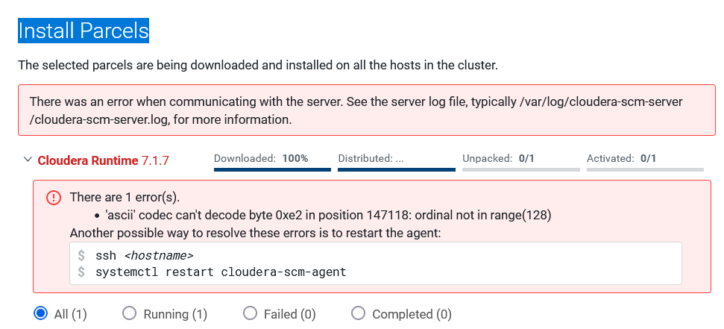

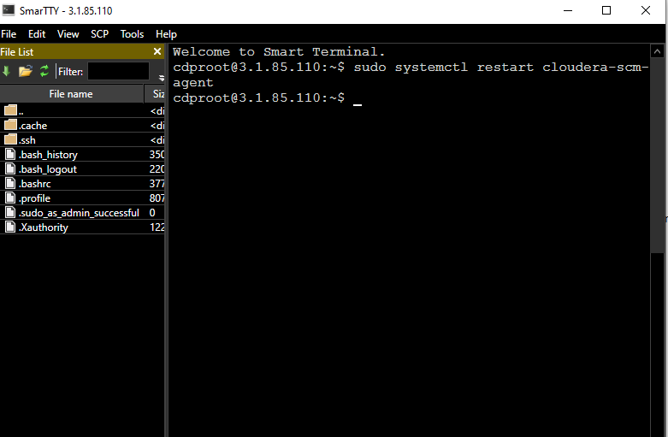

* 1. **Check FREE STORAGE NEED FOR UNPACKING PARCELS:**

$ df <options> [devices], df /dev/sda

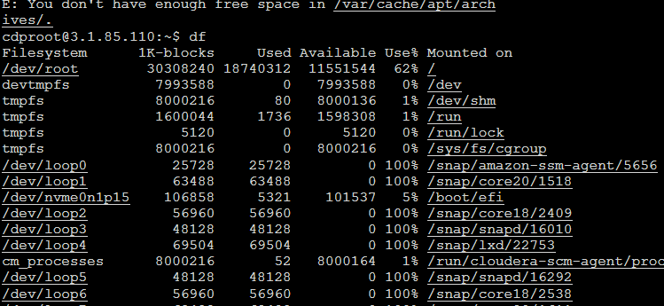

Check installing small package: sudo apt-get install gedit 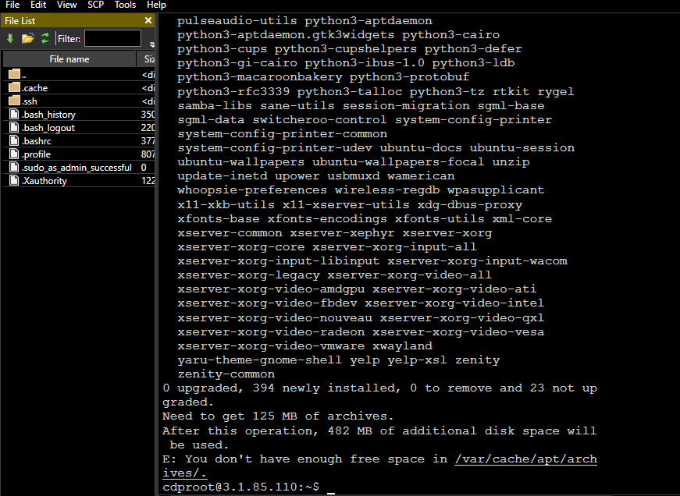

* 1. **Check Whether download Package available or not:  
     Location :** oudera/parcels/.flood/CDH-7.1.7-1.cdh7.1.7.p0.15945976-focal.parcel/CDH-7.1.7-1.cdh7.1.7.p0.15945976-focal.parcel does not exist 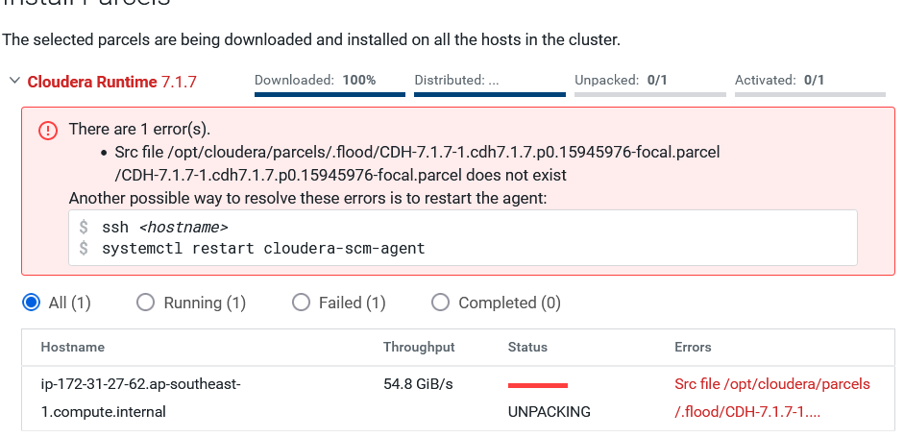

/opt/cloudera/parcels/.flood/CDH-7.1.7-1.cdh7.1.7.p0.15945976-focal.parcel  
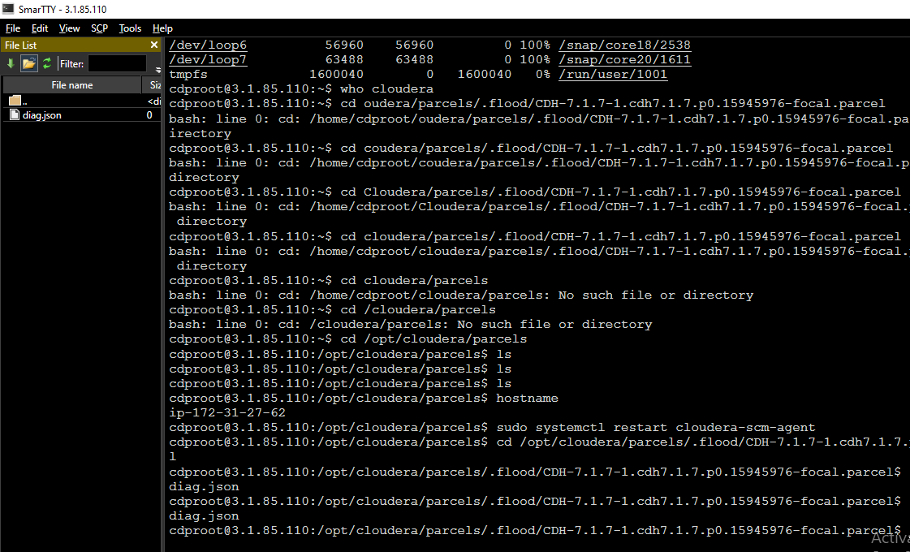

1. TS-02: Trial License Issues  
    Write with environment details for Trial License at <https://www.cloudera.com/contact-sales.html>  
   

